SOURCE WATER PROTECTION PROGRAM

BLUE-GOLD CERTIFICATION

For businesses in Dayton’s Multi-Jurisdictional Source Water Protection Area

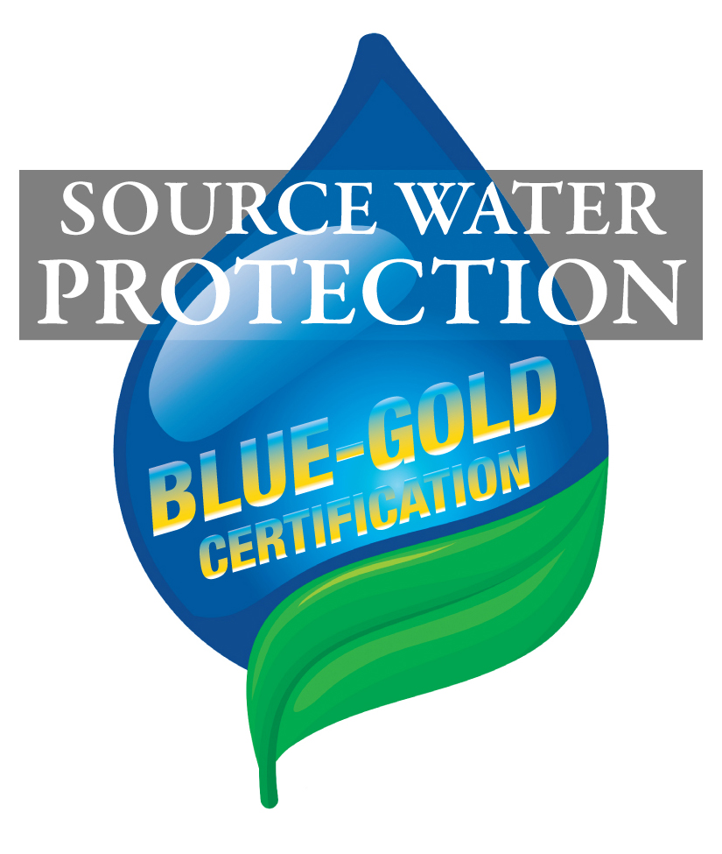

******************************** IMPORTANT ********************************

A MINIMUM OF 37 POINTS IS REQUIRED TO RECEIVE BLUE-GOLD DESIGNATION.
The Source Water Protection Program is a Multi-Jurisdictional approach to guarding the public water supply of 400,000 customers in Dayton and Montgomery County. This is multi-barrier protection program includes preventative efforts, risk reduction and protection strategies. By participation in the Blue-Gold Certification program, your business is demonstrating their commitment to protecting our source water.

Note: All criteria may not apply to your business. For example, if your business does not dispose of hazardous substances because you do not use hazardous substances, mark as Not Applicable (NA) and receive 1 point
towards the total points for your business. All Not Applicable (NA) will count as 1 point.

All Conforming Use businesses that meet the Mandatory criteria 1A through 10A are eligible for Blue-Gold Certification.

Secondary containment, engineering controls, and any equipment or devices which reduce risk to groundwater are eligible for funding through the Source Water Protection Fund (see last page).

Owner Name: Conforming Use Site?
Business Name: TMDI:
Business Address:
City: Site Contact:
Zip: E-mail:

A. SOURCE WATER PROTECTION PROGRAM (SWPP) – GENERAL (1point each) YES / NA

1A. Site is compliant with the SWPP and the following rules and regulations:
- Backflow prevention per local water authority Mandatory
- Local Fire Department codes, as related to chemical handling
- Ohio State Fire Marshal, Bureau of Underground Storage Tank Regulations (BUSTR)
- Ohio and US EPA regulations and permits

2A. Safety data sheets (SDS/GHS) for all chemicals are accessible to all employees. Mandatory

3A. Spill kit(s) are maintained and available for employees. Mandatory

4A. Emergency response contact numbers are posted in high visibility areas. Mandatory

5A. Vehicle maintenance and washing are performed offsite unless a permitted use. Mandatory

6A Outdoor chemical storage areas are located away from catch basins and dry wells,
are located on an impermeable surface, and are sheltered from weather. Mandatory

7A. Floor drains are protected from chemical leaks and spills. Mandatory

8A. Ensure leaves, grass clippings, general yard wastes are not raked or blown into Mandatory
street or catch basins.

9A. If Dumpsters are used at site, they are covered, isolated from catch basins and Mandatory
dry wells, and located on an impermeable surface.
10A. All containers are properly labeled. Mandatory

(All criteria are scored 1 point each unless noted.)

B. SPILL RESPONSE AND POLLUTION PREVENTION PLANNING NA YES NO

1B. A Spill Prevention & Response Plan, or SPCC if required, is available for review
during SWPP inspections; all employees have access. (5 points)

2B. The Storm Water Pollution Prevention Plan, required for NPDES permit, is available
for review during SWPP inspections. (3 points)

3B. Outside site drainage plans are available for review during SWPP inspections. (2 points)

4B. Floor drains are connected to sanitary sewer; in lieu of plumbing plans, conduct dye test.

5B. Inspect all secondary containment systems and emergency response equipment at least
quarterly and have maintenance log(s) available for review during SWPP inspections.

6B. Pollution prevention and spill response training is provided annually for all employees
and documented, including meeting dates and participants. (2 points)

7B. Eliminate illicit discharges to groundwater and the storm system from truck dock drains,
chip bins, etc. using oil-water separators or other engineering controls. These controls are
routinely inspected, maintained, and documented. (2 points)

C. CHEMICAL MANAGEMENT AND HOUSEKEEPING

1C. Chemicals are stored inside unless Fire Dept. Code prohibits inside storage.

2C. Underground storage tanks are equipped with leak detection systems and meet
corrosion protection performance standards.
3C. Under ground (UST) and above ground (AST) storage tanks are double-walled.

4C. ASTs are secondarily contained according to acceptable standards.

5C. Conduct and log routine inspections of USTs/ASTs and have logs available for review
during SWPP inspections.
6C. Drum storage areas are isolated and secure from public access.

7C. Drums/totes/pails are properly stored on spill containment pallets, platforms, or otherwise
properly secondarily contained. (2 points)

8C. Secondary containment is used when handling, dispensing or transferring fluids between
containers. Examples include spill control carts/caddies with containment measures such as
appropriately sized drip pans and/or absorbents.

9C. Chip-bins/Recycle-bins used to collect oil covered material (i.e. metal shavings/grindings)
are covered, sheltered from weather, isolated from catch basins/dry wells, and located on an
impermeable surface. (2 points)

10C. Catch basins/dry wells that are located down gradient of chemical storage areas and
bins containing oil covered material, are protected at the surface or by oil/water separators.
The oil/water separators are routinely inspected, maintained, and documented. (2 points)
11C. All chemicals are stored in appropriate containers and are isolated from any incompatible
materials and/or chemicals.
12C. Combustible and flammable chemicals are stored in flammable cabinets.

13C. Hazardous substances are disposed per federal, state, and local rules and regulations
and have paperwork available for review during source water protection inspections.
(All criteria are scored 1 point each unless noted.)

D. BLUE PURCHASING NA YES NO

1D. Implement "just in time" purchasing policy for chemicals used in processes.

2D. Eliminate the use of products containing chlorinated solvents. (2 points)

3D. Minimize or eliminate use of oil-based chemicals.

E. STORM WATER MANAGEMENT PROGRAM (SWMP)

1E. Properly abandon (cap or remove) dry wells. (5 points)

2E. Install bio-detention/retention basins in areas lacking storm sewers. (5 points)

3E. Storm water retained in outside secondary containment is tested, and properly
disposed of off-site; records available for review during SWPP inspections. (2 points)

4E. A Universal Waste Disposal program has been implemented including the proper
management of materials, training, and disposal of materials per Ohio EPA. (2 points)

5E. Implemented policies in support of Storm Water BMPs; examples include: (1 point each)

- Recycling

- The elimination of the storage and use of lawn chemicals

- Prohibiting car/truck wash at the site

- Preventing erosion during landscaping and construction activities

- Labeling of catch basins with markers or stencils

F. EXTRA CREDIT (All criteria are scored 1 point each unless noted.) YES

1F. Have attended an H2KNOW luncheon?

2F. Have completed a Source Water Protection Site Assessment (SWPSA)? (2 points)

3F. RSAIRs are up to date and submitted every non-inspection year?

4F. Have properly disposed of old and/or unneeded chemicals? (2 points)

5F. Inventory below Total Maximum Daily Inventory (TMDI)? (If YES – Mark one)
- 25% below TMDI (1 point)
- 50% below TMDI (2 points)
- 75% below TMDI (3 points)
6F. Are DRG Green-Certified?
(Source Water Protection Area businesses are encouraged to become DRG Certified. For more information go to www.drg3.org)

7F. Other efforts to protect the groundwater - our drinking water source - Please specify in comment box below.

G. SCORING

Each item is worth 1 point unless otherwise noted.

All NA (Not Applicable) selections are worth 1 point.

A minimum of 37 points is required.

MINIMUM (37) TOTAL FOR BUSINESS ___________ Date ___________________

STAFF RECOMMENDATION: YES / NO

Blue-Gold Certification is awarded to: ___________________________________________________
Business Name

Company Official ______________________________________ Title _______________________________

SWPP Representative ___________________________________ Title _______________________________

Certified Blue-Gold criteria will be reviewed during routine Source Water Protection inspections.

Note: Engineering controls such as outdoor shelters, secondary containment, oil/water separators, spill kits etc., may be eligible for grants or 0% interest loans from the Source Water Protection Fund.

For more information or any questions relating to this application:
- For businesses within Dayton call the Division of Environmental Management at (937) 333-3725.
- For businesses outside of Dayton call Public Health-Dayton & Montgomery County at (937) 225-4460.
- Or go to www.daytonwater.org

SUBMIT

